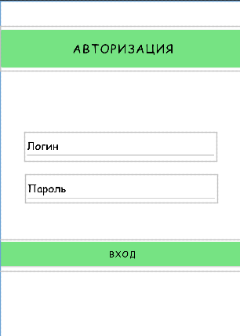

<?xml version="1.0" encoding="utf-8"?>  
<androidx.constraintlayout.widget.ConstraintLayout xmlns:android="http://schemas.android.com/apk/res/android"  
 xmlns:app="http://schemas.android.com/apk/res-auto"  
 xmlns:tools="http://schemas.android.com/tools"  
 android:layout_width="match_parent"  
 android:layout_height="match_parent">  
  
 <Button  
 android:id="@+id/signInButton"  
 android:layout_width="426dp"  
 android:layout_height="53dp"  
 android:fontFamily="@font/comic_sans"  
 android:text="Вход"  
 android:textColor="#000000"  
 app:layout_constraintBottom_toBottomOf="parent"  
 app:layout_constraintEnd_toEndOf="parent"  
 app:layout_constraintHorizontal_bias="0.333"  
 app:layout_constraintStart_toStartOf="parent"  
 app:layout_constraintTop_toBottomOf="@+id/passwordInput"  
 app:layout_constraintVertical_bias="0.182" />  
  
 <EditText  
 android:id="@+id/passwordInput"  
 android:layout_width="327dp"  
 android:layout_height="48dp"  
 android:ems="10"  
 android:fontFamily="@font/comic_sans"  
 android:hint="Пароль"  
 android:inputType="textPassword"  
 android:textColorHint="#000000"  
 app:layout_constraintBottom_toBottomOf="parent"  
 app:layout_constraintEnd_toEndOf="parent"  
 app:layout_constraintHorizontal_bias="0.511"  
 app:layout_constraintStart_toStartOf="parent"  
 app:layout_constraintTop_toBottomOf="@+id/loginInput"  
 app:layout_constraintVertical_bias="0.059" />  
  
 <EditText  
 android:id="@+id/loginInput"  
 android:layout_width="327dp"  
 android:layout_height="48dp"  
 android:layout_marginBottom="460dp"  
 android:ems="10"  
 android:fontFamily="@font/comic_sans"  
 android:hint="Логин"  
 android:inputType="textEmailAddress"  
 android:textColorHint="#000000"  
 app:layout_constraintBottom_toBottomOf="parent"  
 app:layout_constraintEnd_toEndOf="parent"  
 app:layout_constraintStart_toStartOf="parent" />  
  
 <Button  
 android:id="@+id/signInButton2"  
 android:layout_width="419dp"  
 android:layout_height="75dp"  
 android:fontFamily="@font/comic_sans"  
 android:text="Авторизация"  
 android:textColor="#000000"  
 android:textSize="20sp"  
 app:iconTint="#000000"  
 app:layout_constraintBottom_toBottomOf="parent"  
 app:layout_constraintEnd_toEndOf="parent"  
 app:layout_constraintHorizontal_bias="0.0"  
 app:layout_constraintStart_toStartOf="parent"  
 app:layout_constraintTop_toTopOf="parent"  
 app:layout_constraintVertical_bias="0.067" />  
  
</androidx.constraintlayout.widget.ConstraintLayout>

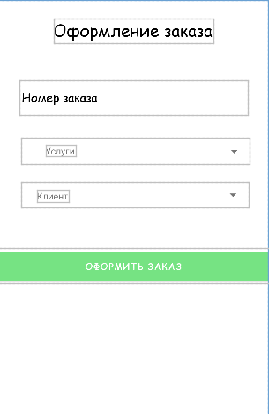

<?xml version="1.0" encoding="utf-8"?>  
<androidx.constraintlayout.widget.ConstraintLayout xmlns:android="http://schemas.android.com/apk/res/android"  
 xmlns:app="http://schemas.android.com/apk/res-auto"  
 xmlns:tools="http://schemas.android.com/tools"  
 android:layout_width="match_parent"  
 android:layout_height="match_parent">  
  
 <TextView  
 android:id="@+id/textView3"  
 android:layout_width="wrap_content"  
 android:layout_height="wrap_content"  
 android:fontFamily="@font/comic_sans"  
 android:text="Оформление заказа"  
 android:textColor="#000000"  
 android:textSize="25sp"  
 app:layout_constraintBottom_toBottomOf="parent"  
 app:layout_constraintEnd_toEndOf="parent"  
 app:layout_constraintHorizontal_bias="0.498"  
 app:layout_constraintStart_toStartOf="parent"  
 app:layout_constraintTop_toTopOf="parent"  
 app:layout_constraintVertical_bias="0.04" />  
  
 <AutoCompleteTextView  
 android:id="@+id/orderNumberInput"  
 android:layout_width="345dp"  
 android:layout_height="51dp"  
 android:fontFamily="@font/comic_sans"  
 android:hint="Номер заказа"  
 android:textColor="#000000"  
 android:textColorHint="#000000"  
 app:layout_constraintBottom_toBottomOf="parent"  
 app:layout_constraintEnd_toEndOf="parent"  
 app:layout_constraintStart_toStartOf="parent"  
 app:layout_constraintTop_toTopOf="parent"  
 app:layout_constraintVertical_bias="0.18" />  
  
 <Spinner  
 android:id="@+id/serviceCollection"  
 android:layout_width="346dp"  
 android:layout_height="40dp"  
 android:fontFamily="@font/comic_sans"  
 android:theme="@style/SpinnerTheme"  
 app:layout_constraintBottom_toBottomOf="parent"  
 app:layout_constraintEnd_toEndOf="parent"  
 app:layout_constraintHorizontal_bias="0.569"  
 app:layout_constraintStart_toStartOf="parent"  
 app:layout_constraintTop_toBottomOf="@+id/orderNumberInput"  
 app:layout_constraintVertical_bias="0.069" />  
  
 <Spinner  
 android:id="@+id/clientsCollection"  
 android:layout_width="344dp"  
 android:layout_height="38dp"  
 android:theme="@style/SpinnerTheme"  
 android:fontFamily="@font/comic_sans"  
 app:layout_constraintBottom_toBottomOf="parent"  
 app:layout_constraintEnd_toEndOf="parent"  
 app:layout_constraintHorizontal_bias="0.552"  
 app:layout_constraintStart_toStartOf="parent"  
 app:layout_constraintTop_toBottomOf="@+id/serviceCollection"  
 app:layout_constraintVertical_bias="0.061" />  
  
 <Button  
 android:id="@+id/confirmButton"  
 android:layout_width="433dp"  
 android:layout_height="54dp"  
 android:fontFamily="@font/comic_sans"  
 android:text="Оформить заказ"  
 app:layout_constraintBottom_toBottomOf="parent"  
 app:layout_constraintEnd_toEndOf="parent"  
 app:layout_constraintHorizontal_bias="0.498"  
 app:layout_constraintStart_toStartOf="parent"  
 app:layout_constraintTop_toBottomOf="@+id/clientsCollection"  
 app:layout_constraintVertical_bias="0.171" />  
  
 <TextView  
 android:id="@+id/textView"  
 android:layout_width="wrap_content"  
 android:layout_height="wrap_content"  
 android:text="Услуги"  
 tools:layout_editor_absoluteX="73dp"  
 tools:layout_editor_absoluteY="219dp"  
 />  
  
 <TextView  
 android:id="@+id/textView2"  
 android:layout_width="wrap_content"  
 android:layout_height="wrap_content"  
 android:text="Клиент"  
 tools:layout_editor_absoluteX="60dp"  
 tools:layout_editor_absoluteY="287dp" />  
  
</androidx.constraintlayout.widget.ConstraintLayout>